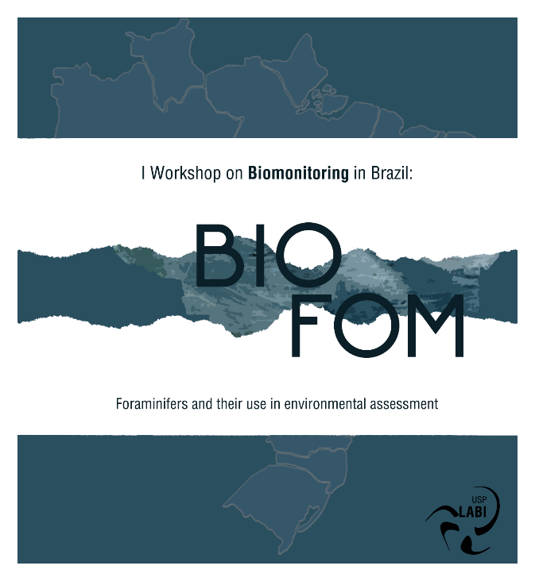

*Name:
*Registration n˚:
*Session:
Type of presentation (Oral or Poster):
Please keep in mind that this is a preference and not binding

Abstract (max 2600 characters including space)

